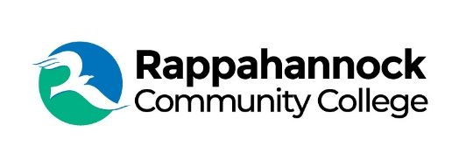

**FOR IMMEDIATE RELEASE**

Rappahannock Community College

Michele Inderrieden

Media Services Manager

[minderrieden@rappahannock.edu](mailto:minderrieden@rappahannock.edu)

(804)333-6824

May 20, 2024

**Rappahannock Community College Honors Graduates at 52nd Commencement Ceremony**

Rappahannock Community College celebrated the Class of 2024 on May 10 in two ceremonies held at Essex High School in Tappahannock. Dr. Shannon Kennedy, RCC president, conferred 882 degrees and certificates at the College’s 52nd Commencement.

In addition to family and friends, RCC faculty, staff, and College Board members were in attendance to honor the graduates. College Board Chair Jamie Tucker, representing Northumberland County, addressed the graduates. “It is now more than ever about understanding yourself so you can become yourself…It looks like to me that you are building that person inside and I am proud to see that RCC has been part of the building blocks to who you are…I hope you listen to that internal G.P.S. and make choices that reflect who you are. You and you alone are the only person who can live the life that can write the story that you were meant to tell. So be aware, be kind, and be true to yourself.”

Essex high school dual enrollment student Logan Taylor was the commencement speaker for the 5 pm ceremony. She spoke about her commitment to volunteerism and giving back to the community, and encouraged her fellow graduates with the following, “We are all entering a new chapter in life, and I wish us all the best! Strive for greatness and reach for the stars as we all have the potential to do great things.”

Gloucester County resident Douglas McTurnal, student speaker at the second ceremony, returned to RCC to earn a certificate in Diesel Mechanics Technology with four separate American Welding Society certifications. He is a firefighter EMT, completed an Associate degree in Arts and Sciences in 1991 from RCC, and is a tribal elder in the Cowlitz Indian Tribe in Washington State. McTurnal spoke about learning from mistakes and never giving up.

Dr. Shannon Kennedy, RCC President, concluded the evening and said, “As you reflect on your time here, I hope you realize that you have grown, both academically and personally. I hope that by attending RCC, you have found your path and know what awaits you.”

Now, as you go forward from RCC to begin your career or transfer to another institution, continue to reach new heights, to inspire others, to do great work, and to always love what you do. Congratulations class of 2024!”

###

Since 1970, Rappahannock Community College has been breaking down barriers to education in the Middle Peninsula and Northern Neck. Five degrees, 6 certificates, and 26 career and workforce studies programs are offered through RCC, in addition to nearly 40 guaranteed admissions agreements with colleges and universities across the state and region. For more information, visit rappahannock.edu.